**Web Design Project**

**Kite for Fun**

##### Lecturer: Leonie Deasy

##### Student: Gilberto Caobianco Junior

##### Student Number: 16108647

**Introduction**

I am new to web design, didn’t know nothing before I started this course. As I am trying to change career I decided to take this course.

My resources for the page are lessons given by the lecturer, websites recommended, and examples from exercises given in the lab classes. I decided to stick with the requirements not going over of what was asked (bootstrap, jquery, etc), because I was afraid of overdoing it and not been able to fully understand my code.

As this is my very first web page, I have kept simple so I can learn while practice more. It is a simple page,involving only basic code because that’s what I really know and fully understand.

**Requirements**

• The site should have a minimum of 4 HTML pages ►

** Your home page should be called index.html **

• Site styling controlled by at least one external CSS file

• Clearly defined, consistent, navigation system • Website must be responsive

• Use of JavaScript (minimum 3 examples)

• Website Deployment Each group will also be required to complete a project report to accompany the website, which should document the whole development process and should include the following information:

1. Website overview

2. Wireframe

3. Production details

► This should include information, such as:

• How you implemented the site requirements outlined above

• Details of noteworthy HTML/CSS/JavaScript implementation

• Details of validation and errors, including how you fixed any errors

• ALL details on third party resources used in project, etc.

4. Website deployment details

5. Details on how your team split the project work, who did what, how well you worked as a team, etc.

**Home Page**

The home page is very basic, in the head we have a line of code for making the page responsive using:<meta name="viewport" content="width=divice-width, initial-scale=1.0">

My first example of using javaScript as per requirement, is the alert box pop up saying “Welcome to our page”. It is a onload function been called externaly.

Then in the next line I am calling the css externaly, the requirement is at least three external css, but I decided to use most of them externaly for good practice and better functionality of the page.

Also I decided to use internal styling, nested inside of a div element. For showing examples of external and internal styling, this styling is on line 30 of the index.html.

I decided to use divs instead of tables following advice of our lecturer, and used some basic tags such as <p></p>, <br/>, <ul></ul> etc, that I got from our exercises in class.

As for the navigation bar the source of my code is taken from w3schools.

“ <http://www.w3schools.com/css/css_navbar.asp> “

Only styled a lit bit of the css to my desired colours, like as for the background colour when you hove over the options in the menu navigation bar.

Then in the body most of the code is from what I learned in class, where I have a div class called x-container with some internal styling, where all the text about my page is located.

The footer is styled to display all the information and images inline, the idea of the footer is also based on external source. I liked the footer on this video given by the lecturer and showed in class

<https://www.youtube.com/watch?v=NtKkSxUjwvU>

Video made by “Drew Ryan”.

The link below is the validation of my index page, where I had only minor problems with, such as not closing a tag, or not closing a tag properly. Mistakes which was easy to fix.

<https://validator.w3.org/nu/#file>

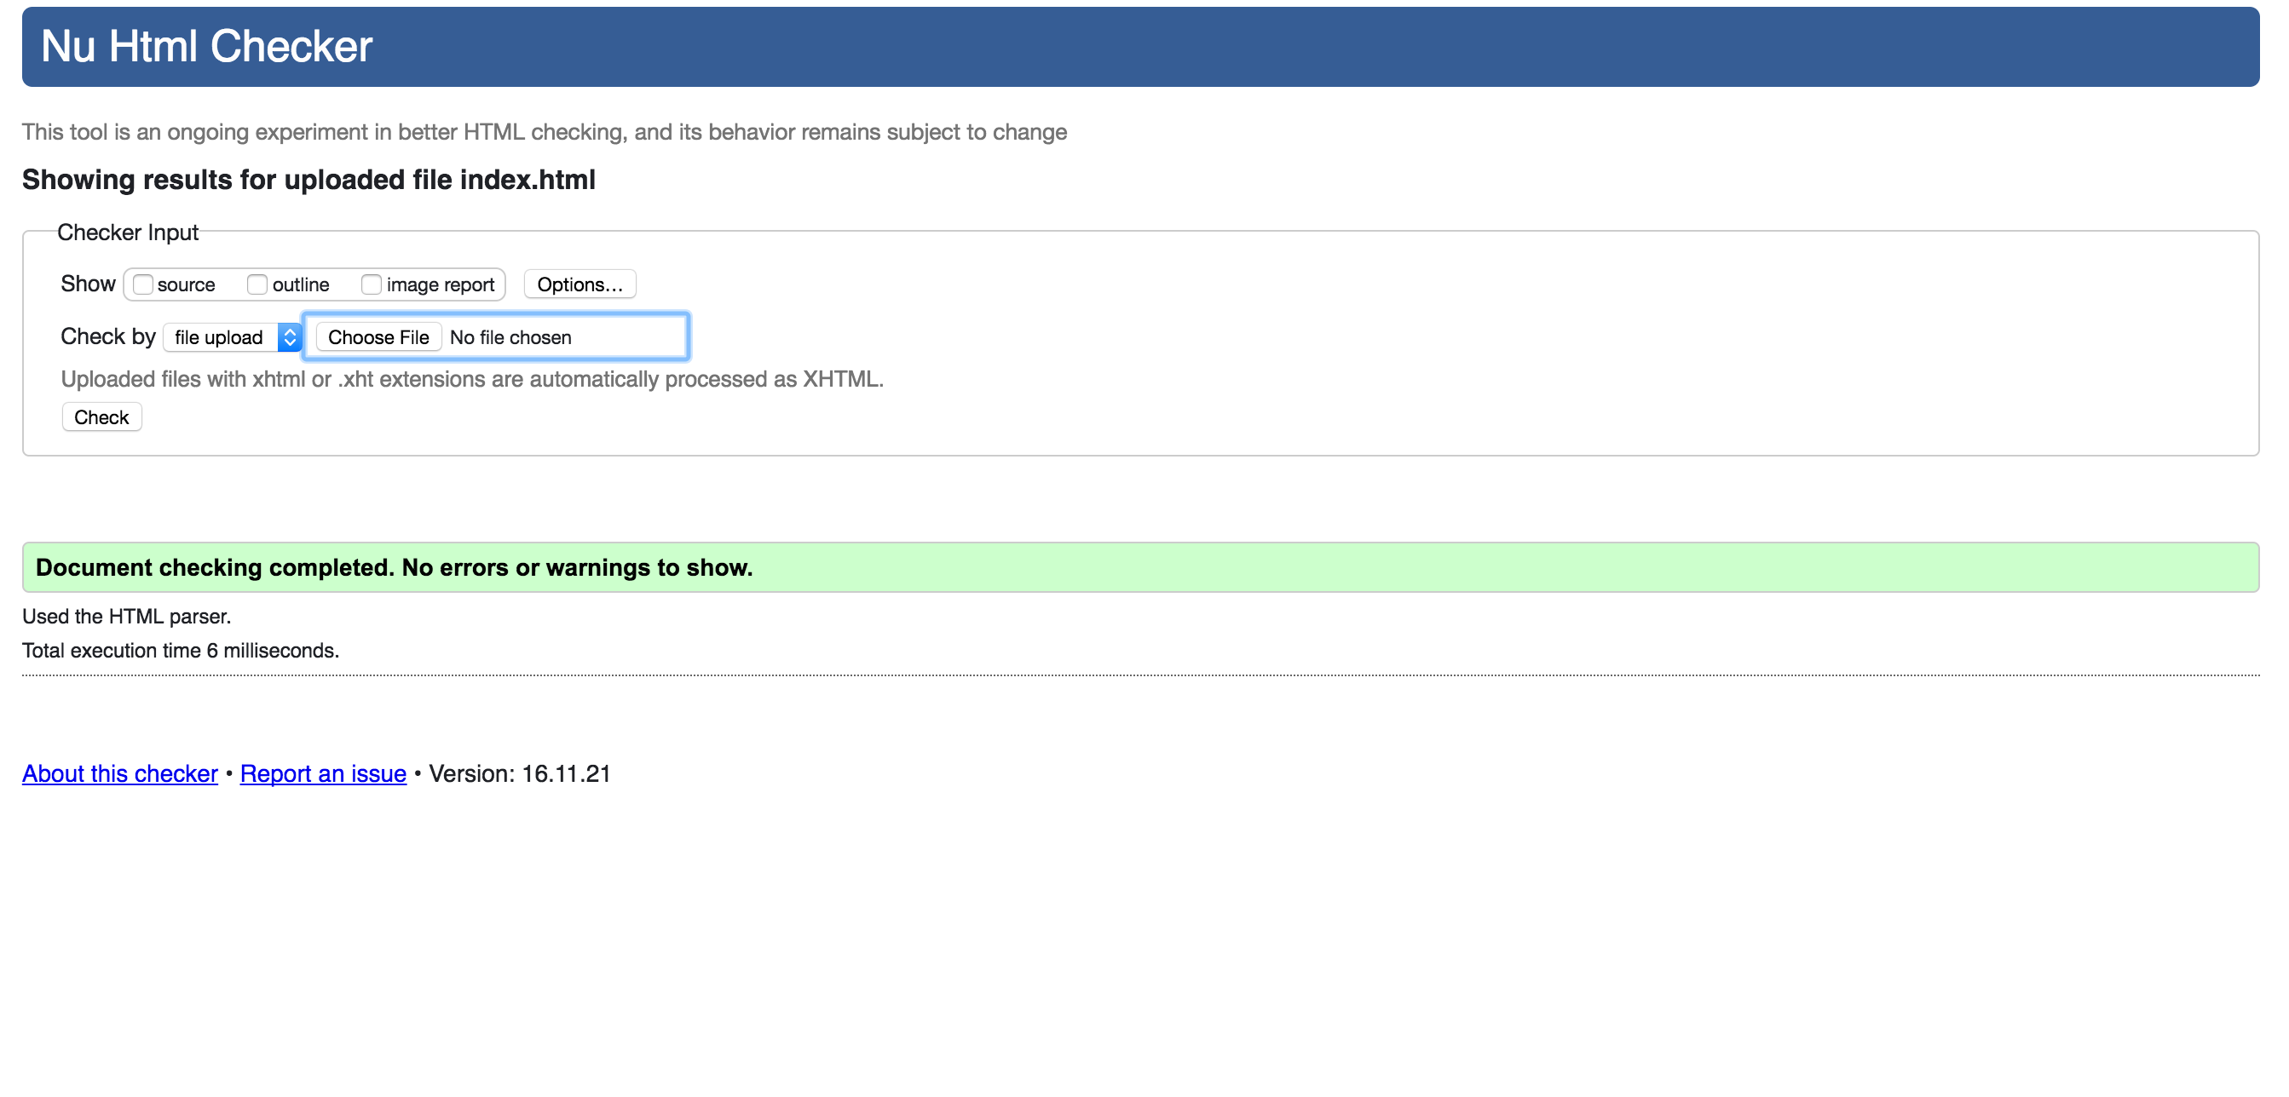

**Photos Page**

My second page is using same format as the index page regarding to make it responsive, also the wrapper tag is used on the same way as it was used in the index page.

The main difference in this page, is the pictures been displayed using a Slide Show with CSS and JavaScript. The code used is based on an example taken by the w3schools page, where I had to change the code a bit for showing more images

“<http://www.w3schools.com/howto/howto_js_slideshow.asp>”

But for not having enough knowledge or experience developing pages and because I really liked that style of displaying images, I took this code from w3schools which is a website recommended frequently by our lecturer.

The divs used to make this works follow same pattern only changing the number sequence from 1 to 7 which is the total of images to be displayed.

Then I call my image given the correct path for it, close the div and repeat 6 times more.

It has a fading animated effect been called by an external css (.fade{ ….})

The previous and next buttons are styled externaly as well, with a effect when you hove over it (.prev:hover, .next:hover {…} line 124). And just above it the style for positioning the buttons (.prev{..} and .next{…} from lines 112 to 121).

Final part of styling is the positioning, colour, border, etc where you can find from line 98 to line 108 (.prev, .next {….}).

Under the slide I have Dots bullet indicators, one for each image, meaning that I have the total of 7 dots which indicate on what image you are on at the moment.

The div for the dots bullet start at line 77 of the photos.html file until line 85

Dots bullet indicators on the bottom of the slide is styled from an external css file, on line 148 (.dot{..}). As for the styling of navigation bar, hearders etc, they follow same process as for the index page. That part of CSS is based on what I learned in class.

Below I have a screen shot of my code validation which I got 3 errors on it but I couldn’t fix it.

All images have been provided by personal friends and some are mine.

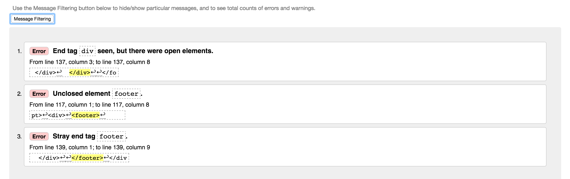

The first error on line 137 saying **End tag**div**seen, but there were open elements.** I checked every element and I couldn’t find anything openned so I couldn’t fix that error. The div on line 137 is the closing div for the <div id=”wrapper”>.

The second error says about the footer not having a closing tag, but I have and when I click on the footer closing tag it points to the opening one, so that I couldn’t fix as well.

Third error is Stray end tag footer, researching about it I found that error usually happens when you use the footer tag outside of the body, which is not my case. Also verified if I am missing quotes, closing tags and errors in all lines, didn’t find any. So I must be missing something that I wasn’t been able to spot.

**Contact Page**

The form used in this page is based on class we had about forms, which I took the same base and styled differently according to my need.

It is a very basic page where most of the page follows same standard of the other pages, navigation bar, wrapper tag, header and footer, all been referenced before. The main difference only is the form itself which is based on a lesson we had in class with a submit button on the bottom as my 3rd JavaScript example fulfilling the 3 examples of JavaScript required.

All the CSS for the contact page is external, and the css file is been called on line 8. Basic css for a basic page of a begginer in developing web pages.

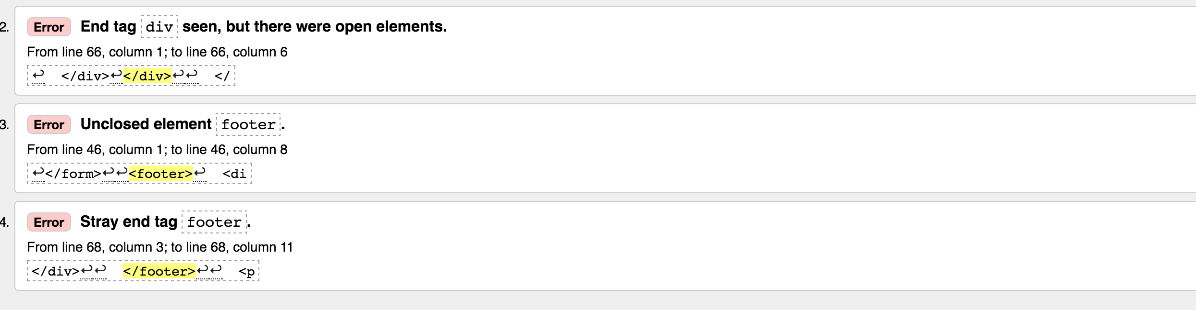

The validation for the contact page I had exactly same problems as I have for the photos page, very same errors and again I went through all tags, line by line and I couldn’t spot the mistake causing this error.

**Buy Now Page**

Starts following the standard navigation bar, and header with the logo already referenced. All the images are placed in a div class called x-container where I used the same code from my index page.

In the bottom we have the footer as been displayed in the previous page as well and referenced.

This page just like the contact page is very basic, where the only difference now are the images displayed inline but basic as I am still learning about web design. I approached displaying the images of the product like that, because in this case the images must be there with the prices without moving around so you the user can see all the products and prices displayed all together.

The list of material nescessary for making the product is very small, therefore no need many images and because I am new to developing I decided to keep it clear and simple.

When validating the code for this page, I came across to errors only, and same errors about the same image.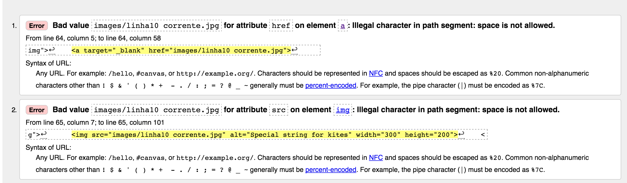

The errors occurred because I had space in the name of the image, so I was calling the image using space, once this was fixed I got no errors on my validation.

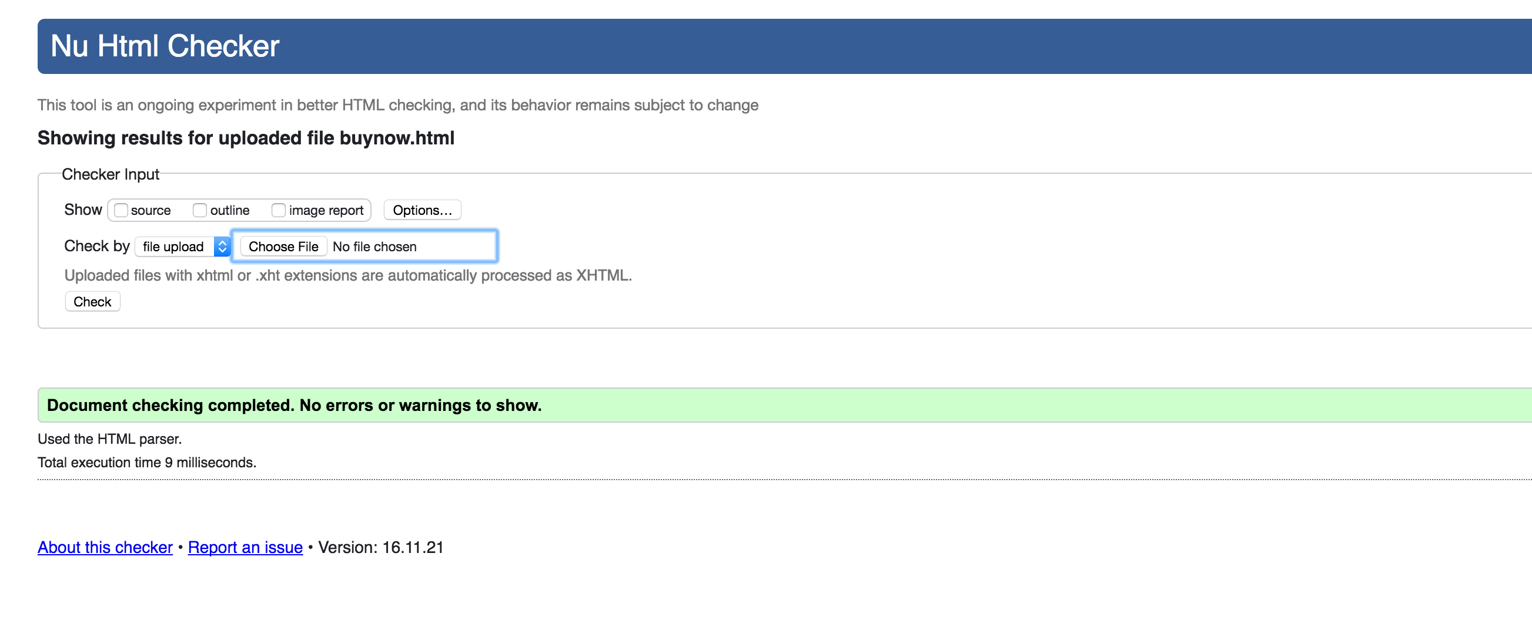

All images are provided by personal friends from facebook and some are mine.

**Deployment**

My deployment was easy enough, I had to get my done through filezilla because I am on a MAC machine. I have created my page in GearHost following the directions provided by the lecturer, then on filezilla I had to figure out how to get this done.

On my first attempt I only got a blue screen saying that the page was created but no content has been deployed. So then after messing with around, I figured out that my mistake was to simply drag the main folder with the whole project inside, so once I dragged the index.html file out of it, I got the main page displayed with no CSS or images.

Then I figured out that it was because the structure on filezilla had to be exactly the same as the structure I have on my machine, then once I got that all in place I had no problem on the deployment process. Now the page is live and running properly, that’s the link for my page:

<http://kitesforfun.gear.host/index.html>